Coursera - Regression Models Quiz 4

*Jean-Luc BELLIER*

*22 décembre 2016*

Question 1

Consider the space shuttle data ?shuttle in the MASS library. Consider modeling the use of the autolander as the outcome (variable name use). Fit a logistic regression model with autolander (variable auto) use (labeled as “auto” 1) versus not (0) as predicted by wind sign (variable wind). Give the estimated odds ratio for autolander use comparing head winds, labeled as “head” in the variable headwind (numerator) to tail winds (denominator) :

* -0.031
* 1.327
* 0.969
* 0.031

Data load

**library**(MASS)

## Warning: package 'MASS' was built under R version 3.3.2

**library**(dplyr)

##

## Attaching package: 'dplyr'

## The following object is masked from 'package:MASS':

##

## select

## The following objects are masked from 'package:stats':

##

## filter, lag

## The following objects are masked from 'package:base':

##

## intersect, setdiff, setequal, union

shuttle2 <- mutate(shuttle,auto=1*(use=="auto"))

View(shuttle)

logreg1 <- glm(auto~factor(wind)-1,family = binomial(link="logit"),data=shuttle2)

summary(logreg1)$coef

## Estimate Std. Error z value Pr(>|z|)

## factor(wind)head 0.2513144 0.1781742 1.410499 0.1583925

## factor(wind)tail 0.2831263 0.1785510 1.585689 0.1128099

Coeffs <- summary(logreg1)$coef

LogoddRatioHeadTail <- Coeffs[1,1]-Coeffs[2,1]

oddRatioHeadTail <- exp(LogoddRatioHeadTail)

oddRatioHeadTail

## [1] 0.9686888

As we can see in the summary, the log of the odds ratio should be the difference between the estimate coefficient for head wind and the estimate coefficient for tail wind. So we need to exponentiate this value to get the odds ratio : ***0.969***.

Question 2

Consider the previous problem. Give the estimated odds ratio for autolander use comparing head winds (numerator) to tail winds (denominator) adjusting for wind strength from the variable magn.

* 1.00
* 0.969
* 1.485
* 0.684

logreg2 <- glm(auto~factor(wind)+factor(magn)-1,family = binomial(link="logit"),data=shuttle2)

summary(logreg2)$coef

## Estimate Std. Error z value Pr(>|z|)

## factor(wind)head 3.635093e-01 0.2840608 1.279688e+00 0.2006547

## factor(wind)tail 3.955180e-01 0.2843987 1.390717e+00 0.1643114

## factor(magn)Medium -1.009525e-15 0.3599481 -2.804642e-15 1.0000000

## factor(magn)Out -3.795136e-01 0.3567709 -1.063746e+00 0.2874438

## factor(magn)Strong -6.441258e-02 0.3589560 -1.794442e-01 0.8575889

Coeffs <- summary(logreg2)$coef

LogoddRatioHeadTail <- Coeffs[1,1]-Coeffs[2,1]

oddRatioHeadTail <- exp(LogoddRatioHeadTail)

oddRatioHeadTail

## [1] 0.9684981

***Answer :*** ***The oddRatio is slightly the same as in previous question : 0.969***.

Question 3

If you fit a logistic regression model to a binary variable, for example use of the autolander, then fit a logistic regression model for one minus the outcome (not using the autolander) what happens to the coefficients?

* The coefficients get inverted (one over their previous value).
* The coefficients reverse their signs.
* The coefficients change in a non-linear fashion.
* The intercept changes sign, but the other coefficients don’t.

logreg3 <- glm(auto~factor(wind),family = binomial(link="logit"),data=shuttle2)

summary(logreg3)$coef

## Estimate Std. Error z value Pr(>|z|)

## (Intercept) 0.25131443 0.1781742 1.4104987 0.1583925

## factor(wind)tail 0.03181183 0.2522429 0.1261159 0.8996402

logreg4 <- glm(1-auto~factor(wind),family = binomial(link="logit"),data=shuttle2)

summary(logreg4)$coef

## Estimate Std. Error z value Pr(>|z|)

## (Intercept) -0.25131443 0.1781742 -1.4104987 0.1583925

## factor(wind)tail -0.03181183 0.2522429 -0.1261159 0.8996402

***Answer :***: ***We can notice that the coefficients reverse their signs***.

Question 4

Consider the insect spray data InsectSprays. Fit a Poisson model using spray as a factor level. Report the estimated relative rate comapring spray A (numerator) to spray B (denominator).

* 0.136
* 0.321
* -0.056
* 0.9457

poisreg4 <- glm(count~factor(spray)-1,family = poisson(link="log"),data=InsectSprays)

poisregcoefs <- summary(poisreg4)$coef

poisregcoefs

## Estimate Std. Error z value Pr(>|z|)

## factor(spray)A 2.6741486 0.07580980 35.274443 1.448048e-272

## factor(spray)B 2.7300291 0.07372098 37.031917 3.510670e-300

## factor(spray)C 0.7339692 0.19999987 3.669848 2.426946e-04

## factor(spray)D 1.5926308 0.13018891 12.233229 2.065604e-34

## factor(spray)E 1.2527630 0.15430335 8.118832 4.706917e-16

## factor(spray)F 2.8134107 0.07071068 39.787636 0.000000e+00

rateSprayASprayB<- exp(poisregcoefs[1,1]-poisregcoefs[2,1])

rateSprayASprayB

## [1] 0.9456522

***Answer :***: ***the estimated relative rate comapring spray A (numerator) to spray B (denominator) is 0.9457***.

Question 5

Consider a Poisson glm with an offset, t. So, for example, a model of the form glm(count ~ x + offset(t), family = poisson) where x is a factor variable comparing a treatment (1) to a control (0) and t is the natural log of a monitoring time. What is impact of the coefficient for x if we fit the model glm(count ~ x + offset(t2), family = poisson) where 2 <- log(10) + t? In other words, what happens to the coefficients if we change the units of the offset variable. (Note, adding log(10) on the log scale is multiplying by 10 on the original scale.)

* The coefficient estimate is divided by 10
* The coefficient estimate is multiplied by 10
* The coefficient estimate is substracted by log(10)
* The coefficient estimate is unchanged

***Answer : The coefficient estimate is unchanged***.

Question 6

Consider the data

x <- -5:5 y <- c(5.12, 3.93, 2.67, 1.87, 0.52, 0.08, 0.93, 2.05, 2.54, 3.87, 4.97)

Using a knot point at 0, fit a linear model that looks like a hockey stick with two lines meeting at x=0. Include an intercept term, x and the knot point term. What is the estimated slope of the line after 0?

* -0.183
* 1.013
* 2.037 *-1.024

x <- -5:5

y <- c(5.12, 3.93, 2.67, 1.87, 0.52, 0.08, 0.93, 2.05, 2.54, 3.87, 4.97)

plot(x,y)

lm1 <- lm(y[1:6]~x[1:6])

lm2 <- lm(y[6:11]~x[6:11])

abline(lm1,col="blue",lw=2)

abline(lm2,col="blue",lw=2)

knot <- c(0)

splineterm <- sapply(knot,**function**(knot) ((x>knot)*(x-knot)))

mat <- cbind(1,x,splineterm)

linreg6 <- lm(y~mat-1)

pred6 <- predict(linreg6)

lines(x,pred6,col="red")

legend(x=-1,y=5, c("With lm","With X"),lty=c(1,1), lwd=c(2.5,2.5),col=c("blue", "red"))

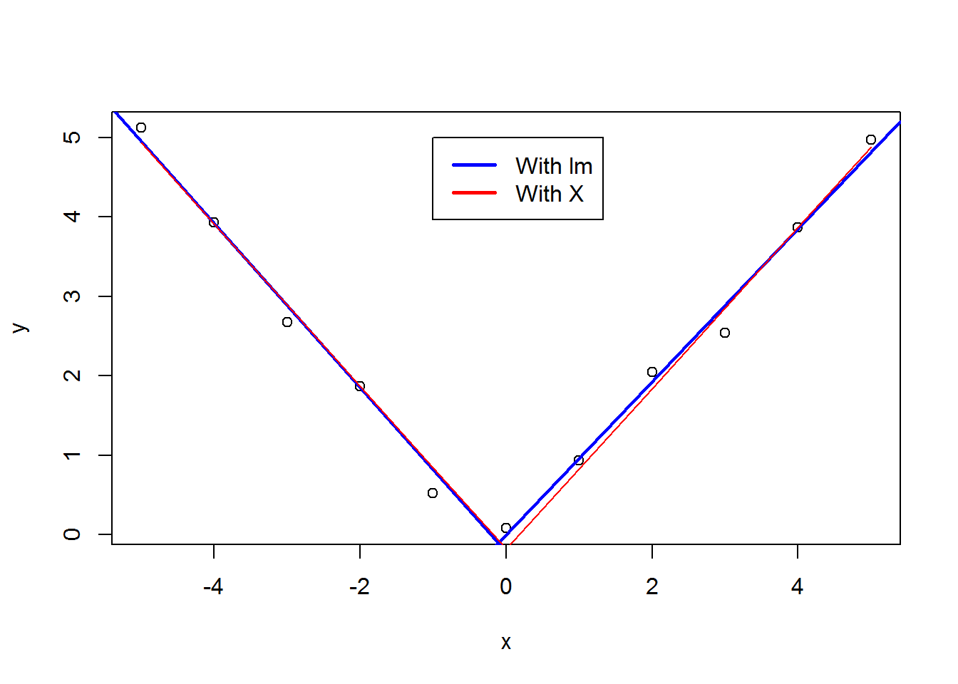

slope = (pred6[11]-pred6[6])/(x[11]-x[6])

slope

## 11

## 1.013067

***Answer : The slope is about 1.013***.